COVID-19 School Operating Procedures

Wheatley Hill Community
Primary School

Head Teacher: Alan Scarr
Chair Of Governors: Jayne Dinsdale
Date: Monday 31st August 2020
Updated – Version 6 – 21/01/21

School COVID-19 Standard Operating Procedures
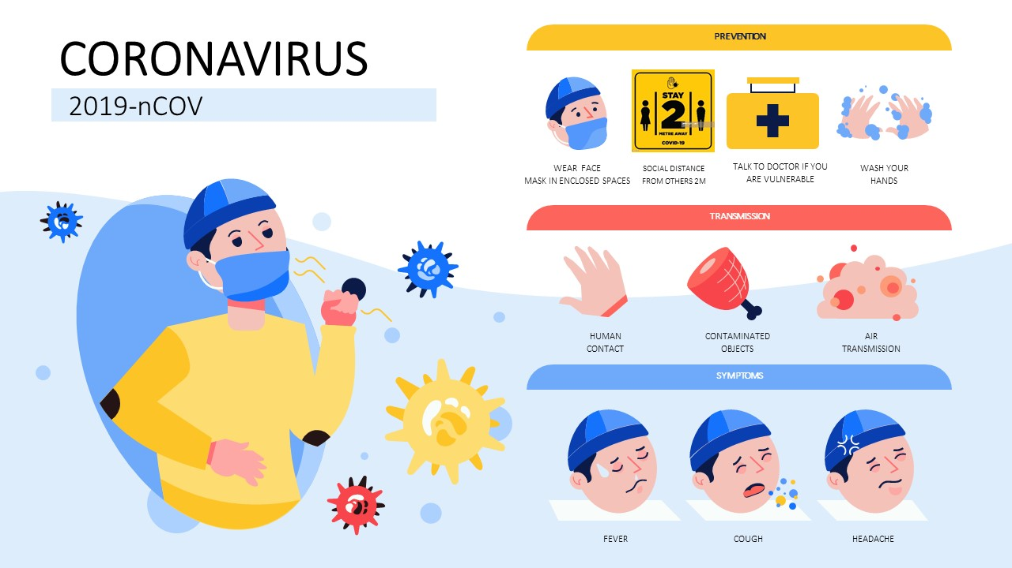This document outlines the COVID-19 operating procedures for Wheatley Hill Community Primary School to support the continuation of schooling for Spring Term 2021. Although we cannot remove the entire risk of COVID-19 entering our school, we will plan to minimise all potential risks of infection & transmission through our detailed planning approach. At Wheatley Hill Primary, preventing the spread of coronavirus involves dealing with direct transmission (for instance, when in close contact with those sneezing and coughing) and indirect transmission (via touching contaminated surfaces). A range of approaches and actions have been employed to do this. This is a set of controls that, when implemented, creates a safer system in school, where the risk of transmission of infection is substantially reduced.

Note – Loss of taste & smell added to symptoms list May 2020.

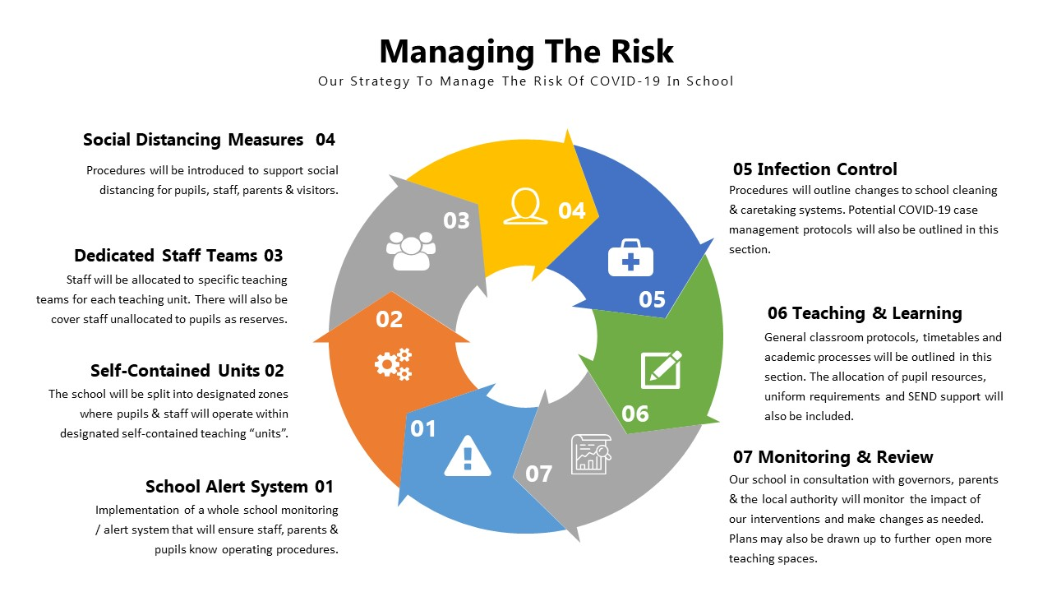
01 School Alert System
In School, we will be introducing our new whole school monitoring system. We will operate within the “Yellow” containment zone in Spring Term 2021 due to Local & National Lockdowns. This means we will be operating with reduced class sizes in school, targeting missed learning & pupil catch up and maintaining social distancing where possible. We must accept that 100% social distancing will not be possible within our units.
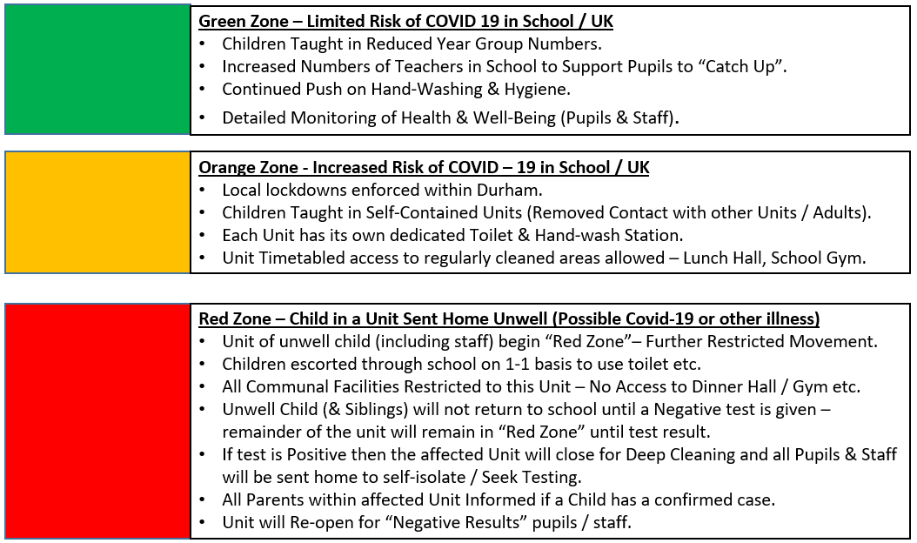

02 Self-Contained Units - Our School Set Up

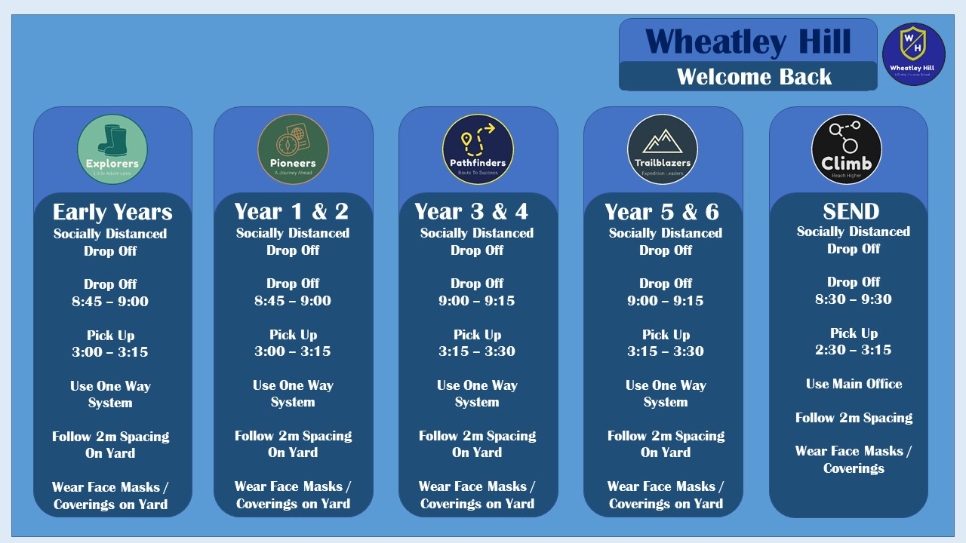
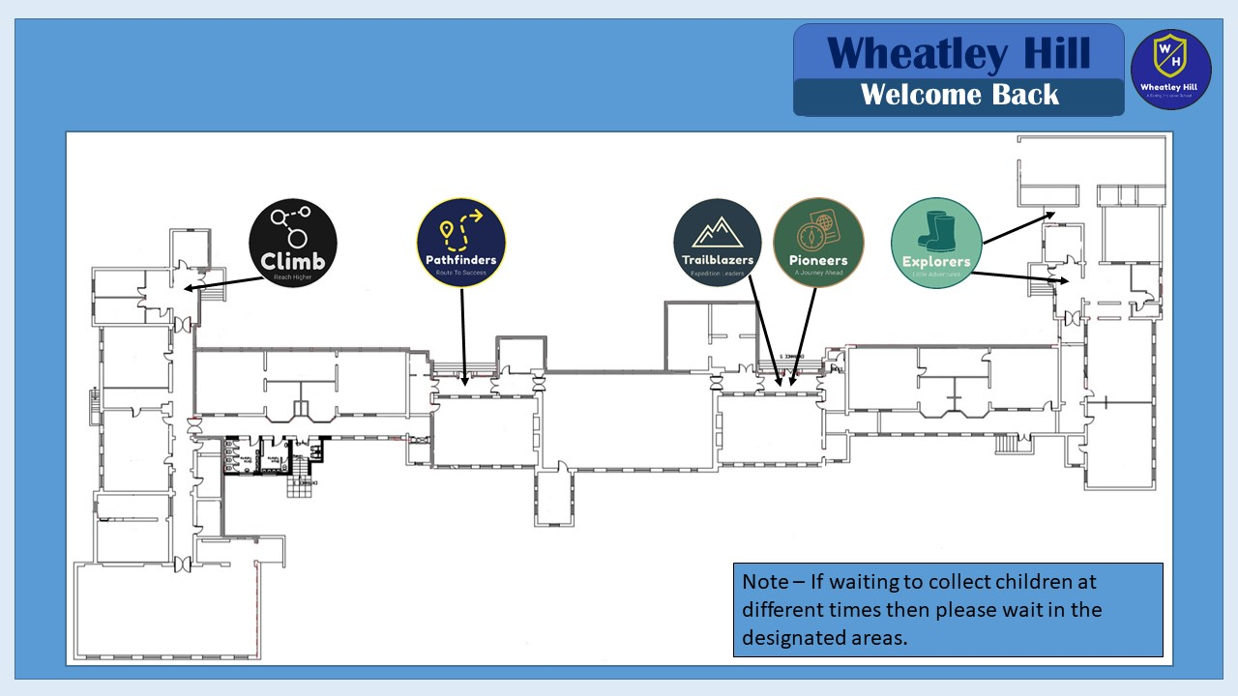

03 Dedicated Staff Teams
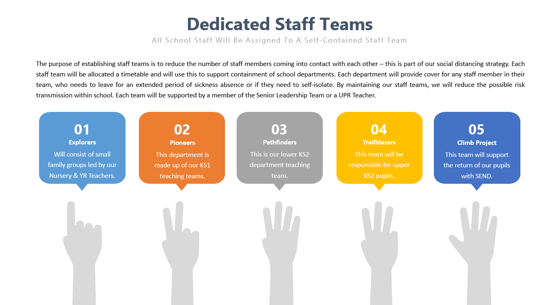
- Staff will be given regular Updates with latest staff & pupil attendance info.

04 Social Distancing Measures

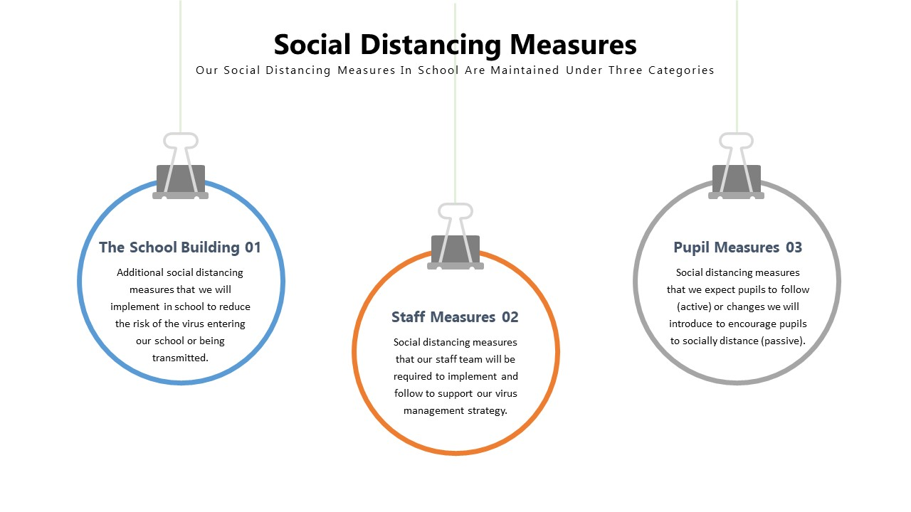
The School Building 01
Overview of Changes to Normal Operating Procedures
In response to the outbreak of COVID-19, there has been a multitude of measures put in place to protect all staff and pupils at Wheatley Hill Primary School. At all times, all staff and pupils must follow social distancing rules of staying 2 metres apart as much as reasonably possible. To limit the potential spread of the virus, the school building has been sectioned into different departments and each department split into smaller class sizes. All staff and pupils are expected to stay within these zones at all times. Each zone has been assigned its own entrance to be used by staff to enter and exit the school. Transitory contact, such as passing in a corridor, is low risk but should be avoided wherever possible (Staff members can wear a mask when transitioning through school). Each classroom has been allocated its own entrance for drop off and collection. Parents have been informed of the expected procedure when dropping off and collecting their children, which includes adhering to social distancing rules, mask wearing and following staggered timings. Measures have also been put in place for those arriving on school transport. Parents will not be admitted into the school building without a prior arranged meeting. All communication will take place over the phone or via the school email address.
The school has undergoes a frequent systematic deep clean in addition to daily cleaning procedures. All classrooms that were not involved in the phased return of children have been cleaned and remained closed to maintain a sterile state ready for the return of children. To ensure that the school remains as sterile as possible, all staff and children must adopt a frequent handwashing routine. To support this, there is an increase of handwashing facilities, cleaning and signage across the school.
Frequently touched surfaces have the potential to spread the virus; therefore, doors of occupied rooms are to be propped open to reduce the use of contact plates & handles. Fire doors in corridors and unoccupied rooms should not be propped open under any circumstance. Toys that cannot be easily cleaned are to be removed from classrooms, where possible, and climbing frames are cleaned daily. To ensure staff and pupils from different classes to not mix, a timetable approach to break times and lunchtimes has been put in place. This is also applicable to outdoor spaces such as the field and forest school.
The front desk is now closed and should not be used by staff to contact the office; instead e-mail should be used. Perspex screens are being installed at key locations around the school to further protect staff. All rooms now have a radio and have been assigned a channel to communicate with colleagues around school as necessary. Should a child or an adult display any symptoms of the virus, there is a designated room for that person to be relocated to until necessary arrangements can be made for them to be collected. PPE is available for anyone supporting someone displaying symptoms. The person in question will not be allowed to return to the school until evidence of a negative test has been provided.
School Gym & Soft Play
Soft play & Sensory Room can be accessed by Climb classrooms outlined on their weekly timetabled slot. Play equipment will need to be cleaned before and after use by the members of staff with their allocated cleaning products.
Hand Wash Stations
Additional hand wash stations and hand sanitizer stations are being set up across school to enable staff & pupils to wash / clean their hands when entering & leaving their teaching units. Wheatley Hill Primary is looking to install additional sink units in the school outdoor areas to support handwashing on enter to school from home / outdoor play.
Staff are to obtain verbal consent from their pupils’ parents that their child can use hand sanitiser and ensure pupils do not have any medical conditions that would prevent them from using it.

Staff Measures 02
Reporting Symptoms and Testing
It is the responsibility of all staff to report any suspected symptoms of COVID-19 immediately to senior management, including at weekends and during school holidays. All staff must ensure that they have made contact with either the Headteacher or Deputy Headteacher to make them aware of any suspected symptoms. All staff should them contact their department head to make them aware that they are showing symptoms and that they have contacted senior management. Under no circumstances should you advise staff, children or parents to self-isolate and book a test unless directly instructed to do so by senior management. If instructed to self-isolated and request a test, it is the responsibility of all staff to immediately inform senior management of the result of a COVID-19 test.

Procedure for Staff Arrivals
All staff should enter and exit the school via their assigned entrance. All staff must proceed directly to their designated department and not congregate with others in shared spaces or corridors. See Staff Handbook & Teaching & Learning Policy for staff arrival expectations.

Communication
Mobile phones are not to be used to communicate in school. Normal usage agreement expectations will be in place as per the Staff Handbook. Radios and school landlines should be the only means of communication. All staff are expected to ensure that there is either a radio or landline in their area of work at all times. Radios must be signed out against their serial number by a member of staff in each work area. That member of staff will be accountable for this piece of equipment. Radios must be stored in a lockable cupboard overnight. Charging of radios should be done periodically. Radios should not be left on charged for excessive periods of time as this can damage the batteries.
Each area is contactable on their assigned radio channel and staff must ensure that their radio is charged and set to the correct channel each day. Staff must ensure that they have switched back to their own channel after contacting a colleague.

Staff Toilets
Staff will be allocated specific toilets to use throughout the day to ensure we maintain social distancing and avoid cross over between our Teaching Units. Staff will keep these toilets clean and report any issues / cleaning needs to the office via telephone/radio.
- Explorers – Nursery staff toilet
- Pioneers – Disabled Toilet
- Pathfinders – Main Office
- Trailblazers – Disabled Toilet
- Climb Project – Main Office
- Admin Team – Main Office
Staff must ensure good personal hygiene and hand wash procedures are followed. Staff toilets will be cleaned throughout the day by the cleaning team. Doors of occupied rooms are to be propped open to reduce the use of contact plates & handles. Fire doors in corridors and unoccupied rooms should not be propped open under any circumstance.

Staff Clothing
Staff to bring a spare set of clothes to school with them in case of body fluid contact / spillages.

Attendance Registers
- Mainstream School to complete register by 9:30am on SIMS.
- Bases to complete register by 9:30am on SIMS.
- For those who do not have access to SIMS please email your registers to wheatleyhill@durhamlearning.net so that the office can populate them on SIMS.

Dinner Registers
- Dinner registers to be completed daily and emailed to wheatleyhill@durhamlearning.net
- Record whether children are having a packed lunch (PL) or a school meal (SM) on the register.

Staff Coffee breaks / Lunch Breaks
In order to support social distancing within school between staff members, the staff room must be carefully used in order to avoid cross contamination of staff groups. Each Teaching unit will create a refreshment station (If needed) in their areas. Health & Safety measures & Risk Assessments should be taken into account, for example, having a kettle in an area accessible by young children is not acceptable nor is closing learning spaces.
- Explorers – Own Kitchen area within the Nursery setting & back of Reception Classroom near toilets.
Pioneers, Pathfinders & Trailblazers – Departments will designate an area within their department to use as a staff area, this should be cleaned use using the provided cleaning facilities.

Notes - Hot drinks should not be consumed in the classroom whilst children are present or carried through corridors. Staff are welcome to have water-bottles for use at any time throughout the day. Staff should consider the use of long-life milk that can be stored safely within their rooms and consider their lunch choices as access to fridges & microwaves may not always be available. Staff should also bring their own cutlery & plates etc. in order to avoid additional cleaning and management of infection control.

First Aid
- Wheatley Hill Primary School has a medication policy in place.
- There are first aid trained staff in each department, and trained paediatric staff are present in the building.
- Each class has a blue school ‘Going Out’ backpack containing a First Aid kit. Classroom staff are required to ensure that the First Aid kits are fully stocked.
- Staff to wash their hands prior to administering First Aid.
- Staff to wear disposable gloves when providing First Aid.
- Staff to wash hands after providing First Aid.
- Staff to wash hands before and after supporting pupils with medication.
- Gloves and First Aid items used must be double bagged and placed in the waste bin.
- Stocks of disposable gloves are available for staff to use.

Emergency Evacuation
- Wheatley Hill Primary School has an Emergency Evacuation procedure in place.
- There is an automatic fire detection system in school, which is tested weekly and inspected annually. The caretaker inspects the alarm control panel at the start of each school day to ensure they system is operating correctly. Any faults are to be reported immediately to the contractor who inspects the schools alarm system.
- In the event of a fire alarm sounding, staff will direct pupils to evacuate the building and go to the Assembly Point on the field at the back of the school.
- Staff to follow the room specific evacuation routes.
- Staff are to monitor the flow of traffic in the corridor areas when evacuating to reduce the contact that pupils have with other age groups/staff members.
- Staff and pupils are to maintain social distancing where possible when evacuating the building.
- Staff and pupils are to maintain social distancing where possible when registers are being taken at the assembly point.
- Staff and pupils re-entering the building is to be staggered.
- Staff and pupils are to wash their hands when they re-enter the building.

Pupil Measures 03
Procedure for Drop Off and Pick Up
To minimise the risk of parents and children gathering in and around the school premises, we have introduced a series of measures that parents and carers must follow when dropping off and picking up children. There are markings on the yard to support social distancing and to help guide children to the correct entrances. We ask, where possible, that children are dropped off at the gate and make their own way to their allocated door. We understand that for very young children (Nursery / Reception) or children with additional needs this may not be possible and parent support may be required.
All parents and children must follow social distancing rules of staying 2 metres apart when they are in or around the school. We ask that parents do not congregate near the school entrances / gates as this may put some of our children at risk. Any parents / carers entering the yard are asked to wear a face covering / mask. Staff members on the yard should also wear a face covering or visor when collecting children from parents on the yard both before & after school. The school has outdoor hand washing stations for children to use before coming into school. No parents will be admitted into the school office without prior arrangement and face coverings must be worn. All enquires are to be made over the phone or via the school email address (support@whprimary.com).
When picking children up at the end of the day, we ask that parents do so promptly in the allocated time as explained on the diagram in section 2. Parents are to wait outside of their child’s allocated door and follow social distancing rules of staying 2 metres apart from others & wearing a face covering. For those parents who need to collect siblings from different year groups, they are to wait in the designated area in between pickups and follow social distancing rules of staying 2 metres apart from others. Parents and carers who choose not to follow these procedures may be asked to leave the school premises.
Sun Cream
Children who bring sun cream into school may use it but the sun cream must remain in school and not be taken home. Children are to apply their own sun cream. If it is necessary for staff to support children in applying sun cream, they must wash their hands thoroughly before and after doing so.
Uniform
Children should be encouraged to wear uniform where possible. However, clean clothes must be worn every day; therefore, lenience should be show if children are unable to wear uniform each day.

Drop Off Times & Locations
Late Arrivals
- Children arriving late are to report to the main school reception who will telephone / radio appropriate zone to open the correct door and remind parents that they must arrive on time in future. A member of the admin team will escort the child across the car park and through the side gate before handing the child over to appropriate department staff.

Pupil Toilets
Pupils will be allocated specific toilets to use throughout the day to ensure we maintain social distancing and avoid cross over between our Teaching Units. Pupils will be encouraged to keep these toilets clean and report any issues / cleaning needs to their staff team, who will then inform the office via radio.
- Explorers - Nursery – Own pupil toilets
- Explorers - Reception – Own pupil toilets
- Pioneers – Girls toilets outside of reception & Dinner Hall Toilets for Boys
- Pathfinders & Trailblazers – Corridor Toilets
- Climb Project – SEND Toilet
Staff must ensure pupils maintain good personal hygiene and that hand wash procedures are followed. Pupil toilets will be cleaned throughout the day by the cleaning team. Doors of occupied rooms are to be propped open to reduce the use of contact plates & handles. Fire doors in corridors and unoccupied rooms should not be propped open under any circumstance. Staff should introduce a toilet / handwashing timetable in conjunction with other teaching units i.e. On the hour, the whole unit goes to the toilet and then thoroughly washes their hands. This will remove the adhoc toilet visits by pupils that could compromise pupil containment.

Sinks, hand wash and hand towels have been installed on the playground so that children can wash their hand before entering the building. Hand towels have been installed in most pupil toilets and an order has been placed so that hand towels can be installed in all remaining toilets. Regular handwashing should take place using classroom facilities where possible or by using the allocated toilets. Handwashing after playtimes should take place using classroom facilities where possible or by using the allocated toilets.

SEND Support
As we are aware, some of our children with SEND will struggle to understand the concept of social distance, however it is important, that as far as possible, we encourage our pupils with SEND to do so as much as they are individually capable of. The SEND bases will operate together as 1 Zone, we will encourage you to not mingle from room to room, but we understand that some of these children will sometimes have moments where you will need assistance to support pupil’s behaviour.

05 Infection Control
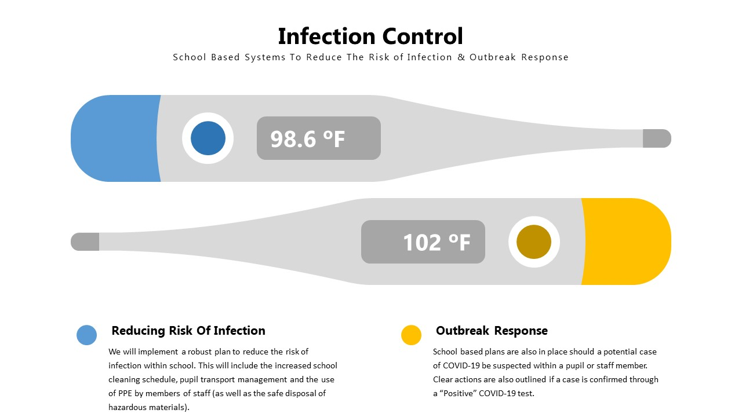
Note – 37 Celsius Normal (98.6)
Reducing Risk of Infection
At Wheatley Hill Primary, it is of great importance that we operate procedures that reduce the risk of infection in our school. Key examples of the practices we will implement include:
- Cleaning hands more often than usual - wash hands thoroughly for 30 seconds with running water and soap and dry them thoroughly or use alcohol hand rub or sanitiser ensuring that all parts of the hands are covered particularly after using wheeled bikes, trikes and other large, movable toys.
- Ensuring good respiratory hygiene by promoting the ‘catch it, bin it, kill it’ approach.
- Cleaning frequently touched surfaces, such as big tables, work stations and door handles etc using standard products i.e classroom cleaning kit.
- Altering, as much as possible, the environment - such as classroom layout and the choice of toys / activities we have out for the children to use. Nothing with intricate parts, or things which pose difficult to clean should be out for the children to use.
- Timetables for each class to separately use the gym, soft play, outdoor SEND garden and forest school areas.
- Toys and equipment need to be cleaned and disinfected regularly, using given detergents and again thoroughly at the end of the day. Resources for activities such as painting, sticking, cutting, small world play, indoor and outdoor construction activities should be washed before and after use and where possible, children should be discouraged from sharing these.
- All children, young people and staff should wash hands on arrival at school, and more regularly throughout the day.
- January 2021 – The introduction of twice weekly Lateral Flow Testing for staff members.

Handwashing
In school, we will promote the practise of diligent hand-washing regimes by all pupils & staff members. Adults will help children to understand how to wash their hands effectively with liquid soap and water. Staff will also support pupils to understand good cough etiquette.
All children will be required to hand wash with liquid soap and water on arrival and at least twice per day thereafter (more frequently, if needed). Adults moving from one room to another or supporting pupils in close proximity i.e. SEND support / EYFS must wash hands before and after moving.
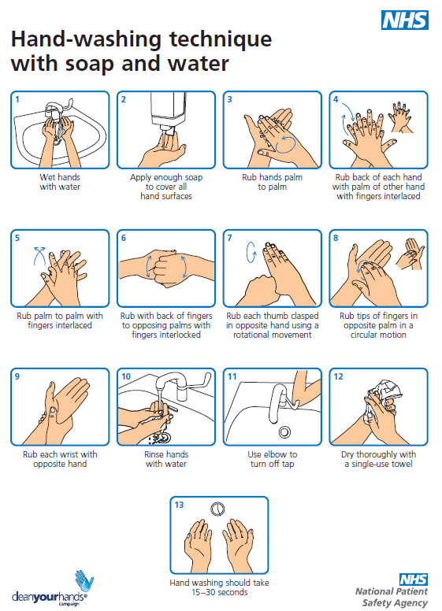
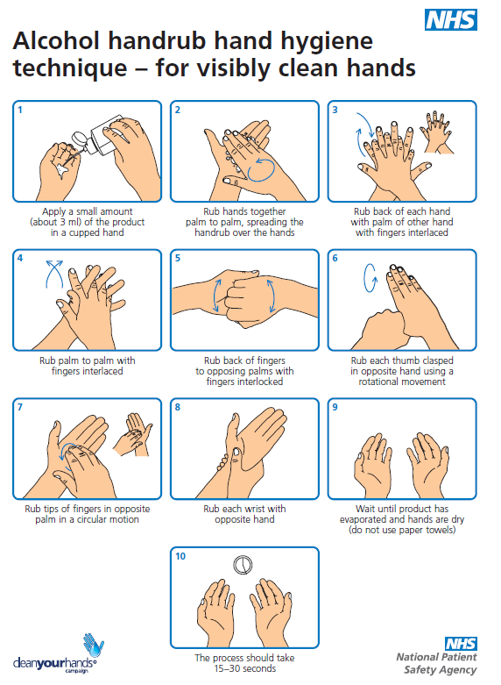

Additional Resources to Support Pupil Handwashing
The following handwashing guidance may be suitable to support younger children or those with SEND.

Further Support
https://www.childrenscommissioner.gov.uk/wp-content/uploads/2020/03/cco-childrens-guide-to-coronavirus.pdf

PPE
Wearing a face covering or face mask in the classroom is not recommended by DfE guidance. Face coverings may be beneficial for short periods indoors where there is a risk of close social contact with people you do not usually meet and where social distancing and other measures cannot be maintained, for example on public transport or in some shops. This does not apply to inside your classroom setting. Schools should therefore not require staff, children and learners to wear face coverings with the exception of meeting parents on the yard or via appointments. Staff are welcome to wear a face covering when transitioning through the school building if they feel comfortable with this.
Changing habits, cleaning and hygiene are effective measures in controlling the spread of the virus. Face coverings (or any form of medical mask where instructed to be used for specific clinical reasons) should not be worn in any circumstance by those who may not be able to handle them as directed (for example, young children, or those with special educational needs or disabilities) as it may inadvertently increase the risk of transmission.
The majority of staff in school will not require PPE beyond what they would normally need for their work, even if they are not always able to maintain a distance of 2 metres from others in their class unit. PPE is only needed in a very small number of cases including:
- Children and young people whose care routine already involves the use of PPE due to their intimate care needs should continue to receive their care in the same way i.e those children who need changing in EYFS or in the SEND bases.
- If a child, young person or other learner becomes unwell with symptoms of coronavirus while in their setting and needs direct personal care until they can return home. A fluid-resistant surgical face mask should be worn by the supervising adult if a distance of 2 metres cannot be maintained. If contact with the child or young person is necessary, then disposable gloves, a disposable apron and a fluid-resistant surgical face mask should be worn by the supervising adult. If a risk assessment determines that there is a risk of splashing to the eyes, for example from coughing, spitting, or vomiting, then eye protection should also be worn. See Outbreak plan for actions around a possible COVID -19 outbreak.

SEND PPE
If a child is in crisis and begins to spit or bite then staff will follow this PPE guidance. In this event, the child needs to be taken to a ‘Safe Space’ (Blue Room) and, if possible, PPE kit should be put on before supporting the child. If more than one adult is needed to support a child in crisis, each supporting adult will need their own PPE kit to wear. Once the child is settled and back in the ‘Green Zone’, but still in the Blue Room, PPE kit will need to be removed and double bagged, dated & stored (72 Hours). The room will need cleaning thoroughly with disinfectant (Classroom Cleaning Kit) before anyone else uses it. This should be recorded to the base classrooms infection control sheet and scanned on to CPOM as usual, with a written report of the event. It is the responsibility of the staff managing the incident to report the incident to the school caretaker to ensure cleaning takes place promptly.
It is recognised that some children and young people with special educational needs present behaviours that are challenging to manage in the current context, such as spitting uncontrollably. It will be impossible to provide the care that some children and young people need without close hands-on contact. In these circumstances, staff need to increase their level of self-protection, such as minimising close contact and having more frequent hand-washing and other hygiene measures, and regular cleaning of surfaces.
School Visitors/Maintenance
The number of visitors on site will be limited as much as possible. All visitors will be asked to maintain social distancing rules and to wash hands on arrival.

Cleaning Schedule
At Wheatley Hill Primary, we believe that a comprehensive cleaning strategy is essential if we are to minimise infection risks within school. In order to achieve this, we will:
- Follow the COVID-19: cleaning of non-healthcare settings guidance.
- Ensure that sufficient handwashing facilities are available. Where a sink is not nearby, provide hand sanitiser in classrooms and other learning environments. Staff should be pro-active to report resupply needs of all classroom cleaning materials and wash products.
- Clean surfaces that children and young people are touching, such as toys, books, desks, chairs, doors, sinks, toilets, light switches, bannisters, more regularly than normal.
  - Ensure adults & children frequently wash their hands with soap and water for 30 seconds and dry thoroughly. Review the guidance on hand cleaning.
  - Ensure all clean their hands on arrival at the setting, before and after eating, and after sneezing or coughing.
  - Ensure all adults & pupils are encouraged not to touch their mouth, eyes and nose.
  - Require all in school to use a tissue or elbow to cough or sneeze and use bins for tissue waste (‘catch it, bin it, kill it’)
  - Ensure that help is available for children and young people who have trouble cleaning their hands independently
  - Consider how to encourage young children to learn and practise these habits through games, songs and repetition
  - Ensure that bins for tissues are emptied throughout the day
  - Where possible, all spaces should be well ventilated using natural ventilation (opening windows) or ventilation units
  - In occupied rooms, doors can be propped open to limit use of door handles and aid ventilation. Fire doors in corridors and unoccupied rooms should not be propped open under any circumstance
  - There is no need for anything other than normal personal hygiene and washing of clothes following a day in an educational or childcare setting
  - Ensure staff (and student) electronics: such as tablets and computers should be disinfected before and after use with antibacterial wipes, and staff mobile phones should be cleaned at least once a day.
Notes – The school will maintain an enhanced cleaning schedule that will incorporate all the above points that will be reviewed and updated.
****See Appendix A for full DCC Cleaning / WHPS Cleaning Systems*****

Training for Staff on the Use of Cleaning Chemicals – Covid-19
If staff, other than caretakers and cleaners are going to be asked to use cleaning chemicals they should be given the following training.
- The COSHH risk assessment for the chemical being used should be read by the user and they must sign to say they have seen it.
- If using the normal school cleaning chemicals, we recommend that caretaking or cleaning staff must prepare any product that needs to be diluted into a correctly, labelled spray bottle, which can then be given to staff to use.
- If a ready to use chemical has been selected – always read the label and follow instructions for use – the school would need a current COSHH risk assessment.
- The caretaker must provide disposable cloths or blue roll to use with the chemical.
- Manufacturer’s instructions must always be followed for dilution and use. The caretaker can explain these.
- Gloves must be worn when using the chemical. Always wash hands before putting on gloves and after removal. If disposable gloves are not available and you are using ‘marigold’ type of gloves, these should be washed and dried before removal. These should not be shared and kept for individual use and the same area – to avoid cross contamination.
- Keep chemicals out of reach of children at all times.
- Do not eat or drink whilst working with chemicals.
- Avoid overspray onto the floor as this could cause a slip problem.
- Wipe up any spillages immediately.
- Dispose of waste appropriately.

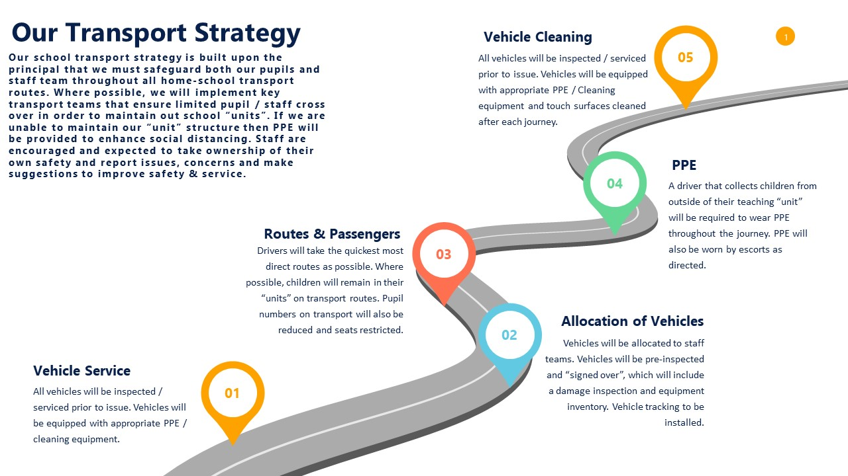Infection Control on School Based Transport

Infection Control on School Based Transport
Vehicle Service
All vehicles will be inspected / serviced prior to issue. Vehicles will be equipped with appropriate PEE / cleaning equipment.

Allocation of Vehicles
Vehicles will be allocated to staff teams. Vehicles will be pre-inspected and ‘signed over’, which will include a damage inspection and equipment inventory. Vehicle tracking to be installed.

Routes & Passengers
Drivers will take the quickest routes as possible. Where possible, children will remain in their ‘units’ on transport routes. Pupil numbers will also be reduced (where possible) and seats restricted (where possible) in accordance with DfE Guidance.

PPE
In compliance with Section 3 of the LA Home-to-School Transport protocol, all drivers, escorts and passengers using home-to-school transport must wear a face covering for the duration of all journeys.

Vehicle Cleaning
Vehicles must be equipped with appropriate PPE/Cleaning equipment. It is the driver’s responsibility to ensure the vehicle is cleaned before and after every trip. The touch surfaces to be cleaned and include:
- Steering wheel
- Handbrake
- Fascias
- Door handles inside and out
- Window handles/buttons
- Seats & hard surfaces around seats that have been occupied

See Appendix C

Potential Outbreak in School
At Wheatley Hill Primary, we have a strategic plan for if a potential case of the virus is identified in school. If a pupil is suspected of having COVID-19 then that pupil will be immediately (including siblings) supported to the Family Room (Our Quarantine Room). Staff should access the quarantine room via the yard and carpark. Telephone / Radio contact must be made with J. O’Connor or School Office, who can open the gate. Ahead of this, the classroom staff team should inform the SLT member on duty in order for parents to be contacted immediately. Prior to escorting the pupil to the Family Room, the supporting staff member will put on their classroom PPE kit. Staff should consider the route they take to the Family room and where possible should use an outdoor route to avoid any potential contact with others. Once inside the Family room, the staff member (wearing PPE) will remain with the pupil at a distance to support them (open windows but keep door closed). School may contact 111 & DCC H&S Team for further advice and guidance if limited contact with parents has been made.
The classroom unit where the potential case has been identified would now move to the “Red Zone” on our school alert system. This would place this unit on lockdown, whereby pupil movement and interactions would be significantly reduced. This class unit would now have lunches within their own room and be escorted to the toilet to ensure no contact was made with others. This teaching unit would remain on “Red Zone” lockdown until a “negative” pupil test was obtained. Following the return of a “negative” test, the classroom unit would revert back to the “Yellow” or “Green Zone” on our school-based alert system.
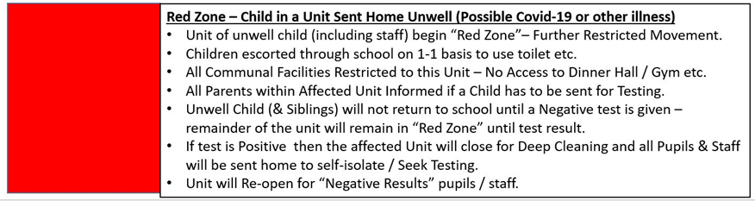
If a “positive” result is returned, then parents will be informed and the entire teaching unit (including units of any siblings & staff) will be sent home to self isolate for 10 days. Pupils and staff will not be allowed to return to the school site until 10 days self-isolation is completed. During this period, the school will support with home learning, meal vouchers or any additional support needed.
Note – Test Results must be seen by senior managers (AS,JH,PG) before pupils / staff can return to school.

National PCR Testing
Staff and pupils in all settings will be eligible for testing if they become ill with coronavirus symptoms, as will members of their households. A negative test will enable children to get back to education, and their parents to get back to work. A positive test will ensure rapid action to protect their classmates and staff in their setting. To access testing parents will be able to use the 111 online coronavirus service if their child is 5 or over. Parents will be able to call 111 if their child is aged under 5.

The government has announced that all essential workers, and members of their households who are showing symptoms of coronavirus can now be tested. This list of essential workers includes education and childcare staff, support and teaching staff, social workers and specialist education professionals in addition to social care staff. Booking is done through a new online system. Employers can register and refer self-isolating staff, and employees are able to book a test directly for themselves or members of their household who are exhibiting symptoms.

Employees can choose to visit one of the drive-through testing sites across the country, or to receive a home testing kit.
To obtain a login to the employer referral portal, employers of essential workers should contact portalservicedesk@dhsc.gov.uk.

Introduction of Lateral Flow Testing in School
The ultimate aim of testing is to break the chain of transmission of COVID-19. As many as one in three people with COVID-19 show no signs of having it, which is they are ‘asymptomatic’. Testing helps us to identify and isolate more asymptomatic people who test positive and are therefore, more likely to spread the virus, at the same time as minimising disruption for those who test negative. Self-testing for COVID-19 is simple, quick and can be carried out at home (or designated sage space in school) without the need to attend a test centre or post samples to a lab for analysis.
The self-test kits are lateral flow devices. The device detects the presence or absence of COVID-19 by applying a test sample to the device’s absorbent pad. The sample runs along the surface of the pad showing a visual positive or negative result. Results are ready in 30 minutes.
The Department for Education expects all primary schools, junior schools, school-based nurseries and maintained nurseries will want to participate and offer at-home test kits to staff. It is voluntary for staff to participate. Once staff understand the testing process and read a privacy notice, if they choose to participate they are committing to self-administer the test and provide their results. Schools should ensure that staff provide their results (positive, negative or void) to NHS Test and Trace via the self-report gov.uk page. Results should also be shared with the school / nursery to support local contact tracing. Staff who decline to participate can still attend school or nursery. People who decline to participate in this testing programme should follow the usual national guidelines on self-isolation and anyone should get tested if they show symptoms.
Primary school staff (including staff in school-based nurseries and maintained nursery schools) will be supplied with at-home Lateral Flow Device (LFD) test kits which they will be able to use twice weekly 3-4 days apart before coming into work, ideally in the morning. Staff at Wheatley Hill have expressed that many of them would like school to provide a safe area for home-testing kits to be administered, in order to allow support and guidance during the initial roll out of staff testing procedures. The LFDs supplied do not require laboratory processing and can provide a quick result in about 30 minutes.
Testing is not mandatory for individuals and they will not need to produce a negative test result, or provide proof of having taken a test, to return to work in person. However, testing is strongly encouraged. LFD tests have been widely and successfully used to detect asymptomatic COVID-19 cases. The speed and convenience of the tests supports the detection of the virus in asymptomatic individuals, who would not otherwise have got tested. LFD tests are approved by the Medicines and Healthcare products Regulatory Agency (MHRA) and are crucial in the fight against the virus. The asymptomatic testing programme does not replace current testing policy for those with symptoms. Anyone with symptoms, whether they are involved in the asymptomatic testing programme or not, will still be expected to obtain a PCR test and follow NHS Test and Trace Guidance, self-isolating until they have received their results. Schools and staff must continue with all current protective measures – asymptomatic testing does not replace these controls or make these less important in controlling the virus.

Test Process
+ Note – See additional Handouts for guidance on administering LFD Test
What happens if a staff member's lateral flow test result is negative?
Staff with a negative LFD result can continue to attend school or nursery after logging their result with NHS T & T. We recommend that they also inform their school or nursery of their result and this will be logged in the school COVID-19 tracking log. Individuals who test negative must continue to follow national and local guidelines including regular handwashing, social distancing and wearing face coverings, where required.
If an individual has a negative LFD test taken at home, can they end self-isolation?
No, individuals must continue to self-isolate. The at home LFD tests are not approved to allow release from self-isolation.
What happens if a staff member's lateral flow test result is positive?
Individuals with a positive LFD result will need to self-isolate immediately in line with the stay-at-home guidance. They should report their results to NHS Test and Trace as soon as the test is complete, as set out in the test kit instructions and self-report gov.uk page. This will enable NHS Test and Trace to monitor the spread of the virus. They must also inform their school or nursery of their result so the school can identify close contacts and they can make appropriate cover arrangements. They should book a confirmatory PCR test online, then continue to isolate for 10 days (from the day the symptoms started) if the PCR test result is positive. The staff member should also inform their school or nursery of a positive PCR result.
At Wheatley Hill, if a staff member’s LFD result is positive, all identified close contacts will be sent home to self-isolate until the positive result is confirmed / overturned by a more accurate PCR test.
What happens if a staff member's lateral flow test result is void/invalid?
If staff get a void result, this means that the test has not run correctly, and they will need to take another test as soon as possible, ideally on the same day. Staff should still report the void result to NHS Test and Trace via the selfreport gov.uk page. They should use a new test kit but not reuse anything from the first kit. In the very unlikely event staff get two void test results, they should book a PCR test. Staff should self-isolate pending the result of the PCR test. Staff should inform their school/nursery as it may indicate a faulty batch of test kits.
What record keeping does the school or nursery need to do?
Schools should keep a test kit log, where they record which individual has taken which kits home. This is required in the unlikely event of an incident requiring investigation or batch recall. This log will also help record that staff have received the new instructions for use. This must be separate from the results register for data protection reasons. Schools should also keep a record of staff tests results. This will help with contact tracing, since schools/nurseries cannot view staff results otherwise. If the individual follows the instructions in the home test kits, they must then record and share their result (whether positive, negative or void) with NHS Test and Trace.
How and when do I report my result to NHS Test & Trace?
Individuals should ensure that they provide their result (positive, negative or void) to NHS Test and Trace. There are two ways you can report your result. You can report online by visiting www.gov.uk/report-covid19-result.
How will my data be stored?
See Appendix D – Privacy Notice

06 Teaching and Learning
We understand that these are extraordinary times. In Spring Term 2021, the most important thing has been to ensure that children of critical workers, and vulnerable children, are being supervised and properly cared for in education settings, whilst also delivering quality Remote Learning to those pupils working from home. Schools have had flexibility to provide support, activities and education in the way they see fit at this time.
Where pupils are taught in school, we would expect teachers to:
- Consider their pupils’ mental health and wellbeing and identify any pupil who may need additional support so they are ready to learn.
- Assess where pupils are in their learning, and establish what adjustments may be needed to their curriculum over the coming weeks.
- Identify and plan how best to support the education of high needs groups, including disadvantaged pupils, SEND and vulnerable pupils.
- Support pupils in year 6, who will need both their primary and secondary schools to work together to support their upcoming transition to year 7.
- Use the Teaching & Learning Policy as a guide.

As children come back to school, it is imperative that we work towards providing children with as much normality as possible. Structured teaching and learning will now need to be provided for those children returning to school. We will aim to provide a broad and balanced curriculum, incorporating a variety of core and foundation subjects. Quality first teaching will take place each morning. The focus of this will be core skills in reading, writing and maths. The school has recently joined Accelerated Reader so it is important that children complete their Star Reader assessment and begin reading ability appropriate books as soon as possible. During afternoon sessions, teachers should aim to deliver lessons for the foundation subjects, using the new progression documents. Marking and feedback should continue to be kept up to date.

The ’new normal’ may have affected children in many different ways; therefore, the mental wellbeing of our children should be at the forefront. A dedicated time to address the social, emotional and mental health needs of the children should be timetabled. This will incorporate the school’s ‘zones of regulation’ approach and advice and support will be available from our school counsellor and inclusion manager.
Our outdoor spaces need to be utilised as often as possible. PE, outdoor learning and physical activity should also be a priority when planning teaching and learning activities each week. We are aware that this adaptive approach may not cover the entire curriculum but at this unprecedented time, these areas are our priority.
Whole School Lunchtime Procedure
All children and adults must wash their hands before and after eating. See School Lunchtime timetable.
SEND Teaching and Learning
The implications which are caused by Coronavirus make it more difficult for school to plan and carry out targets, outcomes and provision in an EHC plan. For example, ‘social distancing’ guidelines may disrupt normal programmes and make certain interventions impractical. In addition, the resources and services needed to secure provision may be reduced, due to the need to direct staff to respond to the pressures generated by coronavirus.
This means we must consider what we need to provide for each child with an EHC plan during this period. For some children, the provision specific in their plan will continue to be delivered, but for others, the provision may need temporarily to be different to that which is set out in their EHC plan.
The priorities for children at this time are resocialisation into new style school routines; speaking and listening, and regaining confidence in school. Sharing stories, singing and playing outdoor games will help all children to socialise and resettle into familiar everyday classroom routines.
Some of our children will have had limited opportunities for exercise. Therefore, they should be encouraged to exert themselves physically, making use of supervised non-touch running games within their bases. Extra outdoor play is encouraged and the use of Forest School and PE sessions in the gym.
Each child will have an individual Risk Assessment which will feed into your Health and Safety files. These will be updated when required to ensure they reflect the current needs of the pupil.
Staff should be mindful that children may be returning to school with some anxieties due to being in their homes for such a long period of time, or may have lost some loved ones in their families. Children with SEND may already have some difficulties with their mental health and controlling their emotions, therefore will need some extra support. All bases are encouraged to support the children
- Opportunities for children to talk about their experiences.
- Opportunities for one-to-one conversations with trusted adults where this may be supportive.
- Some refocused lessons on relevant topics, for example, mental wellbeing or staying safe.
- Pastoral activity, such as positive opportunities to renew and develop friendships and peer groups.
- Extra Zones of Regulation workshops.
- Circle time sessions.
- Gain advice from the school support services for advice and support for individual children.
Home School books should be completed daily with reassuring comments and pictures to show the parents that the children are still having a great time at school. Staff must ensure they wash their hands before and after handling these books.
SEND Base Classroom set up during COVID-19
Rooms should be tidy, organized and fit for purpose
Visual Timetables - so that our children know what they are doing throughout the day. Some children need an individual timetable and some a now and next board. Staff in the room know at what stage each child is at and these need to be in place ready for the children returning to school.
Visually Labelled Areas – Visually labelled areas should be ready for the children’s return, for those children who need to take their next card from area to area.
Big Table – Each base should have a group table. Social distancing should be adhered to as much as possible and the table and chairs need cleaning regularly throughout the day. Particularly before and after lunch.
Zones of Regulation – Display is needed in each base. The children should continue to self-register each time they come into the room (mornings, after outdoor breaks etc.). Techniques should continue to be used to support our children to regulate their emotions. Continue with workshops as needed depending upon pupil needs.
Workstations – Workstations need to be kept free from clutter. Please see the workstation policy to remind yourself how to set the workstations up. Workstations need to be cleaned regularly throughout the day.
Continuous Provision - Small world, blocks, books, trains, cars etc. will need to be cleaned throughout the day.
Sensory – Sensory areas can still be set up in base classrooms, but extra care needs to be taken with soft furnishings, to avoid cross contamination. Please think creatively about how you can manage sensory and movement breaks to adhere with these guidelines. Please contact JH if you need support or ideas with this for particular children.
Outdoor Play – Each base to have their own basket/box of play equipment to take outside during outdoor play sessions.
Lunch for children – Children will have their lunches in the base (Meals will need to be collected from the hall by Base Staff)
SEND General Learning
As much as possible, it is important to keep children in their usual routine. Children should continue to access the gym as usual for their gross motor carousel. Fine motor, handwriting books and ‘Power of’ interventions should continue as should phonics sessions, guided reading, 1:1 reading and keeping a daily record of this in their reading record books.
Marking and feedback should continue to be kept up to date as will black individual journals and base floor-books with captured moments and long observations evident.
Offsite Visits and Outdoor Ed are cancelled for the foreseeable, as are swimming sessions and hydrotherapy.
English and maths sessions will continue to be planned for by the SEND teacher and books will be set up ready for these sessions to be delivered. Foundation subjects should continue to be delivered on an afternoon, with an emphasis on PE, outdoor play and supporting mental health and emotions (as mentioned above).

Remote Education
In the event of a class/bubble having to isolate at home, teachers are responsible for providing a remote learning offer. When providing remote learning, teachers will be available between normal working hours. If they are unable to work for any reason during this time, for example due to sickness or caring for a dependent, they should report this using the normal absence procedure.

What work needs to be set?
- Teachers need to provide remote learning resources for the children in their class.
- There should be an online and paper based offer for children self-isolating, which will include a range of pre-recorded teaching using Oak Academy or created by classroom staff directly.
- Children should have access to 5 maths lessons, 5 English lessons, and a combination of discrete foundations lessons and projects that equate to 5 lessons. Daily tasks for practising times tables and spellings/phonics should also be set.
- Weekly overviews should be added to the shared file as normal.
- Timetables are published on the school website – 4 hours per day KS2 / 3 hours per day KS1.
What should remote learning look like?
- Lessons should use the same L.O. and work system formats as shown in the teaching and learning policy.
- Lesson sequences should be on one PowerPoint and not individual documents.
- Teachers should add additional notes and explanations to PowerPoints for parents. This could be in the form of speech/thought bubbles for example.
- Default fonts (Arial, Calibri, Comic Sans) should be used to ensure that resources are accessible for remote learning.
When does work need to be set?
- Teachers will use the first day of isolation to prepare a 5-day sequence of lessons and resources for week 1.
- Teachers will then prepare for week 2 during their normal working hours of week 1.
- Marking and feedback should be completed during normal working hours.
- Welfare calls should be made twice weekly during normal working hours. Contact numbers can be found on Teachers 2 Parents. Staff should add 141 to all contact so that their number is withheld. Any additional costs can be claimed back.
How will work be shared with children?
- Techers will be provided access to Teachers2Parents & School Website
- Using Teachers2Parents, teachers will be able to email resources to parents via the school email address. Therefore, there is no need for teachers to use their own school email accounts. All work will also be published on the school website – www.whprimary.com/covid19
- Completed work will be emailed by parents to support@whprimary.com and forwarded on to the appropriate teacher.
What will marking and feedback look like?
- Marking and feedback should follow the school’s marking and feedback policy.
- Symbols should be used in place of physical marking ( ).
- Marked work can be sent back to pupils using Teachers2Parents.
How often should contact be made with the parents/carers of children who are?
- Calls should be made for each child twice each week.
- Teachers should ask:
  - How is the child doing generally?
  - How is the child managing the work?
  - Does the child/parent need any further resources or support from school?
How available are staff expected to be?
- All staff should be contactable via phone and email during normal working hours.
- All staff should check their emails periodically throughout the day.
- All staff should attend staff meetings virtually.
- All planning, resources, marking, emails and phone calls should be done during normal working hours.

07 Monitoring and Review
This document will be reviewed weekly and updates shared with the WHPS staff team and governors.
Version 1 - Tuesday 19th May
Version 2 – Friday 22nd May
Version 3 – July 1st
Version 4 – September 1st
Version 5 – 09 /11/20
Version 6 – 21/01/21

Appendix A – School Cleaning Guidance
Durham County Council
Caretaking & Cleaning Support Service - Caretaking & Cleaning During Covid-19 from 1st June 2020
It is imperative to ensure high cleaning standards are continuously maintained, to significantly reduce the possible risk of transmission of the virus.

Everyone should continue to follow Public Health advice

- frequent hand washing
- social distancing (2 metres apart) where possible. Avoid gatherings in the cleaning cupboard.
- if a 2 metre distance cannot be maintained, non-symptomatic staff should work side by side, or facing away from each other, rather than face to face if possible.
- Adhere to the catch it, bin it, kill it rule.
Site Managers and Caretakers should continue to carry out their normal duties e.g. cleaning, maintenance, security, compliance checks and outdoor duties etc.
Ensure you always have adequate supplies of PPE, paper products, soaps, cleaning chemicals and light equipment to carry out cleaning – do not run out!

Caretaking & cleaning staff to continue wear their normal PPE for example, using gloves for cleaning/chemical use.

Refresh your relevant risk assessment and other health and safety procedures.

All health and safety compliance checks should be up to date.

Please refer to the DCC H & S Infection Control Covid19 General Risk Assessment.

If any areas of the school premises have been closed for a period, these must be deep cleaned prior to any re-occupancy.
Try and effectively manage access to areas that have been deep cleaned but are not being used by staff and pupils.
If it is safe to do so regarding fire evacuation, close off the parts of your school that aren't critical, this will make cleaning more manageable and you'll be able to use your cleaning staff more efficiently e.g. close doors & display a sign asking people to keep out.
Caretakers and cleaners should continue to do their normal daily clean.

However, Head Teachers may need to discuss and explain to staff if there is a need to change work patterns, or increase hours, either temporarily or permanently. This is due to this exceptional situation and as outlined in the ‘DCC H & S Infection Control Covid-19 General Risk Assessment’ (attached). It may not be possible for the staff to change due to personal circumstances, so discuss flexibility to try and reach a compromise.
Government guidance recommends cleaning at the ‘end of the day’ – if so, discuss changing any ‘morning cleans’ to afternoon.
To ensure the risk assessment guidance is followed you may decide to have some cleaning provision through the day – if so, discuss changes to working times.

Daily Cleaning
Regular daily cleaning should be carried out using the normal cleaning chemicals and practices.
If these chemicals are not available, Greenham will offer, pre-approved alternative products.
- Follow our DCC School Cleaning Frequency for Schools for normal cleaning (attached).
- We have created a Covid-19 cleaning regime checklist as suggested in the risk assessment which you may find helpful.
- Protocol for colour coding of equipment should be followed.
- All equipment should be cleaned thoroughly after each use and stored correctly.
Frequently Touched Points
In addition, follow the risk assessment guidance for frequent touch points, such as:-
- taps & toilet flushes
- door & window handles
- touch plates, push plates
- light switches
- access pads/panels
- keyboards
- banisters & handrails
- fingerprint scanners & sign in screens
- water dispenser
- waste bin lids
The risk assessment suggests using a disinfectant. Use your usual disinfectant cleaner e.g. Shield. Remember to always follow manufacturer’s instructions for use & dilution.
Keep Duomax and bleach solutions for an infection control clean if needed.
Have wipes or your usual school cleaning product available for staff, if they wish to clean some items/equipment themselves during the day. The caretaker should prepare cleaning solution for use in a spray bottle, which must be clearly labelled and kept out of reach of the children. For example – Sprint Hard Surface Cleaner. They can use disposable cloths or blue roll. Staff should wear protective gloves when carrying out this task.
They should be given training and see the COSHH risk assessment for any products they are using, and sign to say they have seen it.
Under normal circumstances caretakers and cleaners are not responsible for cleaning toys and books, therefore they will require additional time if you request them to do this.
Other Considerations for Cleaning
Sharing:
- cleaning will be needed between different groups of children if they are to use shared areas, equipment and resources.
- this also includes outside play equipment, seating etc.

Remove:
- unnecessary items from classrooms and other learning environments where there is space to store it elsewhere.
- soft furnishings, soft toys & hard to clean toys (those with intricate parts).

Cleaning after a Symptomatic or Confirmed Case
If you have a confirmed case, you must contact Public Health for advice
Equipment & PPE
- Staff should use colour coded disposable cloths and mops.
- Staff should have disposable PPE such as gloves, aprons.
- A disposable mask may be required if a risk assessment of the setting indicates that a higher level of virus may be present or there is visible contamination with body fluids. If unsure, the local Public Health England (PHE) Health Protection Team (HPT) can advise on this.
- Avoid creating splashes or spray when cleaning.
- Disposable cloths must be renewed for each classroom, toilet area etc. and cleaning water changed regularly.

If you have or have had, symptomatic or a confirmed case in school, all surfaces that they have come into contact with should be cleaned and disinfected by either using: -
- Duomax – it is a cleaner disinfectant that has been tested for use against this virus. It does not need to be diluted. It is bleach and alcohol free and safe to use in school.
http://www.duo-max.com/coronavirus
OR
- your normal cleaning chemicals, followed with a 10% bleach solution in a bucket. Bleach must not be used in a spray bottle or with hot water.
OR
- or another cleaner disinfectant that is effective against enveloped viruses.

Remember to always follow manufacturer’s instructions for use & dilution.

Floors – use your normal cleaning chemicals, but if bodily fluids are present, clean and disinfect the affected area only, as above.

Take care as some floors could be damaged by chemicals or a slip problem could occur.

If, after the above clean, you feel a spray disinfection of the school would be beneficial please contact us for details of DCC Pest Control who are offering this service.

Symptomatic people should use a separate bathroom if possible or needed whilst waiting to leave. The bathroom should be cleaned & disinfected before being used by anyone else.

Also:
- Items heavily contaminated with body fluids that cannot be cleaned by washing should be disposed of.

Afterwards
- All other equipment, such as mop handles, buckets etc. should be disinfected after each use.
- Machinery, handles, hoses should be disinfected.

Waste
- All waste, cloths, mop heads and the disposable equipment/PPE should be double bagged and tied
- It should be stored separately in a suitable and secure place for at least 72 hours, then it can be put in normal waste.

Public Health Guidance
https://www.gov.uk/government/publications/covid-19-decontamination-in-non-healthcare-settings/covid-19-decontamination-in-non-healthcare-settings

DURHAM COUNTY COUNCIL
CARETAKING & CLEANING SUPPORT SERVICE
COVID-19 CLEANING FREQUENCY FROM 1ST JUNE 2020
DEFINITION
These tasks are a suggestion of what may be required throughout school, however it is not exhaustive. You should always ensure that, all surfaces must be clean, free from dust, dirt, debris and graffiti, chewing gum, food, grease, grime and bodily fluid deposits.
FLOORS – should be cleaned appropriate to finish, contact your support officer for advice.
=====================
The Health & Safety Infection Control Covid-19 General Risk Assessment identifies that the following items should be added to the school cleaning regime.
Toys* | Books* | Stationery*
External bins | Outdoor furniture | External Handrails
Portable & Fixed Outdoor Play Equipment* | Gates | Entrance Doors & access pads
*These items are not normally the responsibility of the caretaker or cleaners; they would need additional time to undertake these duties.
**these items should be frequently disinfected as per the Health & Safety risk assessment

TOILETS/WASHROOM/SHOWERS
DAILY – these are cleaned & disinfected
Clean all surfaces to include: -
- Empty, clean (including lid** if fitted) & reline bins – as frequently as requested
- Remove litter
- toilets, flushes**, cisterns, urinals, splashbacks, pipework
- sinks, taps**, plugholes, overflows, surrounding surfaces, splashbacks, pipework
- showers, curtains, screens & doors
- door furniture, locks**, handles** & glass
- light switches**
- partitions/cubicle surfaces/cistern boxing
- walls to remove body waste
- soap, toilet roll & paper towel dispensers** (replenish as required as per local arrangements)
- warm air hand dryers
- sills, ledges & skirtings
- mirrors – buff to polish
Sweep and damp mop all floors, including curved vinyl skirtings
Medical bed/nappy changing units – clean all surfaces - Staff that use this should clean after every use
WEEKLY
Scrub around sanitary fittings by hand using a deck scrubber
Clean grilles/louvres/radiators
Wash all tiled and painted walls, toilet cubicles, ledges and fittings to hand height
Pull out medical bed/nappy change unit, sanitary bins to clean under and behind

WHOLE SCHOOL TASKS
DAILY
Empty, clean (including lids** if fitted) & reline bins – as frequently as requested
Remove litter
Damp wipe desks and all other working surface.
Damp wipe chairs
Clean floor appropriate to finish, spot clean carpets as necessary
Clean soap & paper towel dispensers** (replenish as required as per local arrangements)**
Damp wipe finger marks from doors, frames and glass panels
Damp wipe door furniture, including access control pads & buff if required**
Damp wipe mirrors & buff to a polish
Damp wipe handrails, bannisters and accessible lift**
Damp wipe medical beds/nappy change units.** Staff using these should clean after each use
Damp wipe kitchen unit fronts and worktops
Fridges, check daily and remove spillages – clean all external surfaces
Clean all external surfaces of toaster, microwave, dishwasher, kettle, water boiler
Damp wipe walls to remove marks
Sensory room – clean all padded surfaces
Lift rugs – vacuum and clean beneath if required but at least weekly
Desktop computer equipment, telephones, intercoms, access control pads/buttons**
Sanitise drinking water outlets**
TWICE WEEKLY
Burnish/spray clean hard floors appropriate to finish
WEEKLY
Damp wipe vents & radiators
Pull out mobile furniture to clean under and behind
Damp wipe benches
Damp wipe doors and frames**
Remove cobwebs
Clean mat wells
Clean (where accessible):
- skirtings, sills and ledges
- shelving
- trunking
- picture frames
- glass panels and display cases.
- free standing lamps and lights
- direction signs/firefighting equipment
- spot clean carpets and upholstered furniture
MONTHLY
Pull out domestic sized equipment to clean all external surfaces and floor/bench under and behind
Nursery/reception - check and shampoo carpets, rugs & upholstered furniture.
Vacuum upholstered furniture

PERIODIC TASKS
TOILETS
To be planned for school holidays – half termly/termly. These tasks should be evenly spread throughout the year to ensure good standards are maintained.
- Scrub toilet floors, use a deck scrub around sanitary fittings if machine cannot access
- Remove limescale build up and encrusted deposits from ceramic and stainless-steel surfaces
- Wash/dust walls and ledges to ceiling height
- Wash doors and frames
- Dust other walls
- Clean extractor grill covers
WHOLE SCHOOL
To be planned for school holidays – half termly/termly. These tasks should be evenly spread throughout the year to ensure good standards are maintained.
- Damp wipe walls to hand height
- Scrub floors and (if required) buff – moveable furniture to be pulled out to clean under and behind.
- Shampoo carpets, rugs and upholstered seating.
- Clean internal glass
- Wash doors & frames, to include grills/louvres
- Clean hard furniture to include chairs
- Empty, defrost and clean internal surfaces of fridge
- Clean/dust wall lights

ANNUALLY – a deep clean of all areas should be undertaken once per year. Best practice is to start from high to low levels. Ideally, rooms should be systematically cleaned, furniture grouped at one area to allow thorough cleaning as detailed below.
- Clean internal surfaces of kitchen units in staffroom
- Wash or dust wall surfaces appropriate to finish to ceiling height
- Deep clean all furniture – to include all surfaces e.g. underside of tables and chairs and legs.
- Clean pupils’ trays, storage trays/boxes if empty
- Clean/dust blinds as specified
- Clean all light fittings – CARETAKER
- Remove chewing gum from all surfaces including furniture
- Strip and polish floors as required
- Renew seal on wood floors where necessary – Summer holidays only
- Clean windows – depending on local arrangements.
- Clean all indoor and outdoor play equipment such as climbing frames, playhouses.

Please contact us for a deep clean checklist if required

Wheatley Hill Primary School – Daily Cleaning Tasks
Wheatley Hill Primary School – Daily Cleaning Tasks
Wheatley Hill Primary School – Daily Cleaning Tasks

Appendix B – DCC School COVID-19 Risk Assessment

Infection Control COVID-19 General Risk Assessment Form Can be found on our school website – www.whprimary.com

Appendix C – DCC School Transport Protocol
This protocol builds upon the earlier Primary, Secondary and Special School (maintained) Home-to-School Transport Protocol, published on 16th June 2020, and sets out expectations and key guidance for transport contractors, their drivers and other staff, for leaders, managers and staff who work in schools and other settings, and for parents and carers of passengers on school and social care transport in respect of transport from the beginning of September 2020.
The protocol draws on national guidance and is aligned with DCC Public Health guidance in order that consistent practice can be applied across schools and other settings in County Durham, and by the contractors who provide transport to these.
The protocol is intended to direct contractors and help schools/other settings complete essential risk assessments, prior to the transportation of an increasing volume of passengers.
New national guidance regarding school transport was included in a document covering all arrangements for resumption of schools published on 2 July 2020 and subsequently updated on 27 July 2020 (note - there were no material changes regarding transport).
https://www.gov.uk/government/publications/actions-for-schools-during-the-coronavirus-outbreak/guidance-for-full-opening-schools
This protocol also draws on further guidance, published on 11 August
https://www.gov.uk/government/publications/transport-to-school-and-other-places-of-education-autumn-term-2020/transport-to-school-and-other-places-of-education-autumn-term-2020
Please note that national guidance is subject to change and this protocol could be affected by such changes; DCC will endeavour to update and issue revised versions of the protocol should this be necessary.
Introduction
The national guidance documents that apply to this protocol are
- Guidance for full opening: schools, Section 2: School operations.
- Transport to school and other places of education: autumn term 2020
The guidance draws a distinction between ‘dedicated school transport’ (carrying pupils only) and public transport (routes that are also used by the general public). It is proposed that the guidance relating to dedicated school transport is also applied to dedicated social care transport.
Dedicated Transport:
- There will be no expectation that a 2 metre or 1 metre plus social distance will apply from September on dedicated transport.
However:
- Where possible pupils should be grouped together on school transport in the bubbles that are adopted within school (i.e.: they should, where possible, be seated in year groups).
- Hand sanitiser should be used on boarding and disembarking.
- The systematic cleaning of vehicles (see section 6) will be observed
- Passengers will be required to queue in an orderly manner and board carefully
- If distancing can be maintained (i.e.: on part-full vehicles) it should be.
- Face coverings must be worn by all passengers over the age of 11, where there are no medical or other reasons not to (see section 3).
Section 1: General Principles:
- There remains in place a general direction to parents and carers – namely that if a child or service user has symptoms, or someone in their household does, they must not attend school or other setting.

In these cases, the following guidance applies: Staying at home guidance

- Sustained social distancing of 2m is impossible to achieve in most situations involving transport. It is therefore essential that care is taken in every other respect to avoid transmission of infection:

- Wherever reasonably practicable, seats alongside the driver must not be used by passengers

- Wherever reasonably practicable, seats immediately to the rear of the driver should not be used; a temporary clear plastic screen to isolate the driver from passengers should be installed where possible.

- Rear-facing seats that face other seats are out of use.

- Drivers, passenger assistants, children/young people/social care users are to wear a face covering for the duration of all journeys, (exceptions as outlined below - Section 3).

- Procedures for boarding and alighting from transport will be regulated by the driver, as detailed in this protocol (section 4).

- The driver has the authority to instruct passengers about where they should sit in order to maintain safety, and this should be respected by passengers (Section 4).

- Where a passenger wilfully fails to comply with instructions from a driver, this will be treated as a serious matter with sanctions that could include the immediate removal of entitlement to travel.

- Drivers (and other staff employed by contractors) will need to receive training from their employer so that they can respond appropriately in a range of situations outlined in this protocol (Section 5).

- Vehicles will be regularly cleaned following steps outlined in this protocol to prevent the spread of infection; drivers will maintain a responsible hygiene regime as outlined in this protocol. (section 6).

- In the event that a passenger starts to show coronavirus symptoms during transportation, the actions outlined in this protocol will be followed (section 8).

- If a child/young person/social care user is unwell at their school or setting, the expectation is that, wherever possible, they will be collected by a member of their family or household. However, where this is not possible, the protocol outlines steps that would offer a driver safe means of providing transport to take the passenger home. (sections 8 and 9).

- Maintaining consistency: the same driver should be used for the operation of the contract unless exceptional operational circumstances make that impossible on a given occasion.
Section 2: Restricted occupation of available seats:
It is for contractors to determine the most appropriate seating arrangements in their vehicles that will allow safe practices to be observed, in accordance with this protocol. While there will be no expectation that a 2 metre or 1 metre plus social distance will apply, the approach to dedicated transport should align as far as possible with the principles underpinning the system of controls set out in the latest guidance and with the approach being adopted for a particular school. Where possible this should reflect the bubbles that are adopted within school; unless directed otherwise, pupils normally should be grouped by year group.
Section 3: Face coverings:
All passengers over the age of 11 using transport must wear a face covering for the duration of all journeys, unless there is a legitimate reason not to (see below).
Additionally, face coverings are not required by children for whom doing so would create a medical risk, including anxiety. It is also acknowledged that wearing face coverings will not be possible for a large proportion of passengers with special education needs and disability (SEND), not least because many would try to remove them and/or would become distressed.
Legitimate reasons not to wear a face covering
Passengers do not need to wear a face covering if they have a legitimate reason not to. This includes:
- if they have a physical or mental illness or impairment, or a disability that means they cannot put on, wear or remove a face covering
- if putting on, wearing or removing a face covering would cause severe distress
- those who rely on lip reading, clear sound or facial expressions to communicate
Drivers and Passenger Assistants must wear face coverings, unless allowable exemptions apply; in such circumstances, contractors will inform the Integrated Passenger Transport (IPT) team immediately and an individual risk assessment will be undertaken.

There may be a small number of children and young people who present additional risks as a consequence of their SEND. For these children and young people individual risk assessments will be required and developed by school leaders based on current guidance.
Section 4: Safe boarding of vehicles and safe transit:
Boarding when travelling to school/other setting: each passenger will be required by the driver to sit in a seat appropriate for the bubble arrangements, unless specifically agreed otherwise due to reasons of passenger welfare.
In a vehicle with multiple pick-ups, the passenger(s) boarding must do so one at a time, maintaining distance from the driver and other passengers, and sit where instructed to by the driver.
The driver has the authority to instruct passengers about where they should safely sit in accordance with this protocol. If instructions are not complied with, the matter should be immediately reported to the driver’s employer and thence to the IPT team (DCC) for urgent attention. The probable sanction is likely to be the immediate removal of entitlement to travel.
For children/young people/social care users using a power or manual self-propelled wheelchair, see Section 9.
Boarding at school/other setting for home journey: every effort should be made to load passengers in a manner which maintains the school bubble arrangements; or where agreed, in reverse of drop off order (i.e. last drop-off should board first, sitting in the rearmost available seat).
Alighting the vehicle: Passengers alighting at the same stop should do so from the front of the bus, rearwards i.e. those at the front of the vehicle alight first, with those in the rearmost seats last.
Seatbelts: To avoid proximity between driver and passenger, parents/carers should be asked to encourage their children/the social care user to put seatbelts on themselves, as far as possible. Where assistance is required (likely to be youngest children), the parent/responsible adult should be encouraged to assist when boarding at home so long as it does not involve close proximity to another child/service user, in which case a face-covering is required to be worn by the parent/carer.
When boarding at school or other setting, the school staff in the child’s “bubble” or the local setting staff may be able to assist as required. However, where applicable, the legal responsibility of drivers to ensure a seat belt is worn properly is unchanged; but normally a visual check should be sufficient.
Section 5: Training:
The contractor is accountable for training drivers and other staff on the necessary actions they must take to keep themselves and others safe, in line with this guidance. This should include the safe wearing of PPE, when and if it is required: there are guidance posters and instructions available for this purpose from Public Health England.
https://assets.publishing.service.gov.uk/government/uploads/system/uploads/attachment_data/file/878677/PHE_11606_Putting_on_PPE_062_revised_8_April.pdf
https://assets.publishing.service.gov.uk/government/uploads/system/uploads/attachment_data/file/878678/PHE_11606_Taking_off_PPE_064_revised_8_April.pdf
Section 6: Cleaning and hygiene:
Each vehicle must be carefully cleaned before and after every trip.
Regularly clean all surfaces, including:
- steering wheels, handbrake and fascia;
- door handles, inside and out; window handles/buttons;
- seats and hard surfaces around seats that have been occupied.
Normal cleaning products are sufficient for the purpose, including disinfectant wipes where available as these are quick and effective to use and can be disposed of easily in a safe manner.
Drivers must use tissues to catch coughs and sneezes. Used tissues should be disposed of in a bin with lid or re-sealable plastic bag as soon as possible.
Drivers must wash hands frequently with soap and water (e.g. by keeping a bottle of water and soap in the vehicle for this purpose), doing this for at least 20 seconds each time. Sanitizer gel can also be used but must contain a minimum of 60% alcohol. Drivers must not leave cleaning products/sanitizer where passengers can reach them.
If a driver needs to come close to a passenger – for instance, to check or assist with a seatbelt – this action can usually be done safely without the need of PPE. Maintain distance wherever possible, wash hands frequently and maintain clean surfaces as described above. If a visor is available, it may also be worn but must not be worn while driving. Drivers should consider that face visors may distress some passengers such as younger children.
However, some situations may require the use of PPE, and these are described in Section 7, below.
Ventilation: Drivers must ventilate their vehicle with opened windows wherever possible (but be aware of the need to avoid risk of children leaning out of windows).
Do not set air conditioning or ventilation systems to recirculate air.
Parents/carers and teachers/care staff should help by requiring all children/young people/social care users using transport to wash their hands thoroughly before each journey.
Parents/carers and schools/other settings should seek to minimise the transportation of bags and equipment by ensuring passengers do not bring anything with them that they do not need.
Section 7: PPE requirements for each vehicle:
Under normal circumstances, i.e. there is no indication that any passenger has the symptoms of Covid-19, current guidance states that there is no requirement for PPE to be worn, apart from a face covering as stated in Section 1.
DCC Public Health guidance identifies equipment that drivers and passenger assistants, where present, may need in emergencies. If a child/young person/social care user starts to display coronavirus symptoms in a vehicle, PPE must be worn. It must also be worn when transporting a passenger home who has displayed symptoms while at school/other setting and no parent or carer is available to provide transport.
In either of these circumstances, PPE must be worn by the driver and Passenger Assistant, where present, if:
- a vehicle with a bulkhead is not available, or
- a strict distance of at least 2 metres cannot be maintained between the driver and the passenger and/or
- a risk assessment determines that the supervising adult is at risk of splashing to the eyes from, for example, coughing, spitting or vomiting.

The PPE required in these instances would be as follows:
- a fluid-resistant surgical face mask;
- disposable impervious gloves;
- a disposable plastic apron;
- if a risk assessment determines that there is a risk of fluids entering the eye from, for example, coughing, spitting or vomiting, then eye protection should also be worn.
For these reasons, a small supply of the PPE listed above must be available in all vehicles used to transport passengers from home to school/other setting and back.
It is the responsibility of the employer to provide PPE as described. In the event that a contractor is unable to source the necessary PPE, they should speak with the IPT team who may be able to provide advice.
Section 8: What to do if a passenger displays symptoms:
If a child/young person/social care user appears unwell with symptoms on the run to school/other setting:
On arrival at school/other setting, before any passengers alight, the driver should immediately inform the appropriate school/setting staff about the concern. The school/setting will take responsibility for handling the situation.
If a child/young person/social care user displays symptoms while at school/other setting:
Any child/young person/social care user who starts displaying coronavirus symptoms while at their school/setting should, wherever possible, be collected by a member of their family or household.
In exceptional circumstances, where this is not possible, the school/setting needs to take responsibility for transporting them home. Where, by agreement between the contractor and the school/setting, this is undertaken by a home-to-school/social care driver, the following steps must be taken:
  - if possible a vehicle with a full height partition screen between the driver and the passenger should be used.
  - A vehicle of sufficient size must be used where the driver and passenger can maintain a distance of 2 metres from each other.
  - The driver must use PPE as outlined above.
  - The passenger should wear a face mask if they are old enough and able to do so.
  - Other passengers should not travel on the transport at the same time as the passenger with symptoms
Section 9: Additional information relating to passengers with specific needs
As is the case in all situations where transport is provided for passengers with specific needs, operators would be required to continue to work with individual schools/settings to implement risk assessments for specific passengers where necessary. Note: this may lead to specific PPE requirements for the driver and/or passenger assistant. Once completed, Risk Assessments are to be notified to IPT.
As in Section 3, consideration needs to be given to the order in which passengers board and alight a vehicle, but some passengers have a particular wellbeing need to exit a vehicle promptly and this should be accommodated if it does not compromise the safety of the driver or passengers.
Many passengers with special needs prefer to sit in the same seat for each journey and, where possible, this preference should be accommodated if it does not compromise the safety of the driver or passengers.
Wheelchairs:
When travelling in a power or manual self-propelled wheelchair, where able to do so, passengers will be encouraged to self-propel into the vehicle or drive their chair in. Where a manual attendant-pushed wheelchair or mobility buggy is used, the driver or passenger assistant will be responsible for getting the chair onto the transport, in accordance with their training (i.e.: some vehicles have wheelchair lifts).
The driver will then secure the wheelchair into place inside the vehicle as per their accessible vehicle training. This will require the driver to come into close proximity with the passenger, so they should aim to work from the sides and avoid close face-to-face proximity and observe a careful handwashing regime as outlined in Section 6.
The legal responsibility of drivers to ensure the chair is properly secured in the vehicle remains unchanged.
Passenger Assistants
In carrying out their role, Passenger Assistants will often need to come into close proximity with the passenger, so they should aim to work from the sides and avoid close face-to-face proximity. The wearing of a face covering and following careful handwashing regime are essential.
Additional information to be read in conjunction with other sections of this Protocol:
Seatbelts - some passengers with special needs cannot fasten /unfasten their seatbelts without help. (see Section 4)
Car seats - some smaller children sit in car seats which should be kept for individual users and not shared. The same will apply for harnesses and other specialist equipment. There should be frequent cleaning according to the instructions in Section 6.

Appendix D – COVID-19 Testing in School Privacy Statement

Wheatley Hill Primary School – COVID-19 Testing of Staff in Primary Schools Privacy Statement
Ownership of the Personal Data
To enable the Covid-19 testing to be completed at Wheatley Hill Primary, we need to process personal data, including the sharing of personal data where this is allowed under data protection legislation. Wheatley Hill Primary is the Data Controller for the data required for the management of tests and implementing local arrangements in the event of a positive test.
We will process personal data relating to staff under article 6.1(f) of the UK GDPR – it is necessary in the legitimate interest of the data controller. We will process special category personal data under the provisions of article 9.2(i) of the UK GDPR, and Part 1 of Schedule 1(3) of DPA 2018 where it is in the public interest on Public Health Grounds to ensure we can minimise the spread of COVID in a timely manner and enable us to continue to deliver education services as safely and securely as possible. This data is processed under the obligations set out in Public Health legislation (Regulations 3(1) and (4) of the Health Service (Control of Patient Information) Regulations 2002 (COPI)) which allows the sharing of data for COVID related purposes and where it is carried out by a health care professional OR someone who owes an equivalent duty of confidentiality to that data.
Ownership of the Personal Data you share with DHSC
Every time you use a lateral flow test you must report the results. More details can be found here - Report a COVID-19 test result - GOV.UK (www.gov.uk). The Department for Health and Social Care (DHSC) is the data controller for the information that you transfer to them about you and your test results. For more information about what the DHSC do with your data please see their COVID-19 Privacy Notice The school remains the Data Controller for the data we retain about you for the management of tests and implementing local arrangements in the event of a positive test. You should read both this Privacy Notice and the DHSC COVID-19 Privacy Notice to understand how your personal data is used prior to taking a test.
Personal Data involved
The following personal data is processed by the school in relation to your test:
• Name •
Unique code assigned to each individual test and which will become the primary reference number for the tests.
• Test result
For more information about what the DHSC do with your data please see their COVID-19 Privacy Notice
How we store your personal information
The school will maintain a test kit log which will record against your name details of the testing kit which has been provided to you. The school may also record Personal Data about you in its internal COVID-19 results register (the school’s COVID-19 results register will not be shared with DHSC). This information will only be stored securely on locally managed systems with appropriate access controls in schools and will only be accessible to personnel involved in the management of tests and implementing local arrangements in the event of a positive test.
The school will retain its test kit log and COVID-19 results register for a period of twelve (12) months from the date of the last entries made by the school into them.
For more information about what the DHSC do with your data please see their COVID-19 Privacy Notice
Processing of Personal Data Relating to Positive test results
We will use this information to enact our own COVID isolation and control processes without telling anyone who it is that has received the positive test. For more information about what the DHSC do with your data please see their COVID-19 Privacy Notice This information will be kept by the school for period of twelve (12) months by the school and by the NHS for eight (8) years.
Processing of Personal Data Relating to Negative and Void test results We will record a negative and void result for the purpose of stock controls of tests and general performance of the testing process.
Data Sharing Partners
The personal data associated with test results will be shared with
• DHSC, NHS, PHE – to ensure that they can undertake the necessary Test and Trace activities and to conduct research and compile statistical information about Coronavirus.
• Your GP – the NHS may share the information you provide with your GP to maintain your medical records and to offer support and guidance as necessary. Any data you provide to the school will not be shared with your GP.
• Local Government to undertake local public health duties and to record and analyse local spreads.
Personal Data in the school’s test kit log will be shared with DHSC to identify which test kit has been given to which individual in the event of a product recall. The school will not share its internal COVID-19 results register with DHSC.
Your Rights
Under data protection law, you have rights including:
Your right of access - You have the right to ask us for copies of your personal information.
Your right to rectification - You have the right to ask us to rectify personal information you think is inaccurate. You also have the right to ask us to complete information you think is incomplete.
Your right to erasure - You have the right to ask us to erase your personal information in certain circumstances.
Your right to restriction of processing - You have the right to ask us to restrict the processing of your personal information in certain circumstances.
Your right to object to processing - You have the the right to object to the processing of your personal information in certain circumstances. Your right to data portability - You have the right to ask that we transfer the personal information you gave us to another organisation, or to you, in certain circumstances. You are not required to pay any charge for exercising your rights. If you make a request, we have one month to respond to you. Please contact us at wheatleyhill@durhamlearning.net if you wish to make a request.
How to complain
If you have any concerns about our use of your personal information, you can make a complaint to us at Wheatleyhill@durhamlearning.net. You can also complain to the ICO if you are unhappy with how we have used your data. The ICO’s address: Information Commissioner’s Office Wycliffe House Water Lane Wilmslow Cheshire SK9 5AF Helpline number: 0303 123 1113

